**Klára Fedorová**

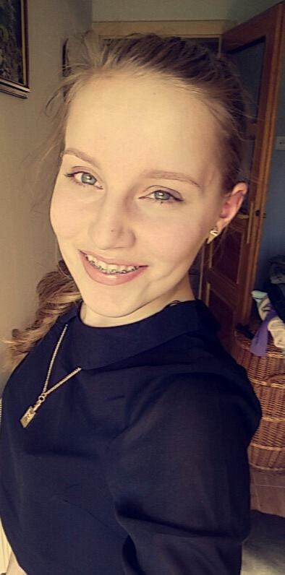Hi, I´m Claire and I am studying interior design on Secondary Technical Schoo in Poprad, Slovakia.. I am 16 years old and my hobbies are for ex.: playing on the piano, singing, photographing, fashion . I have three sisters and one Brother. I live in small village near Poprad. I am very enthusiastic about this project- I want to learn about castles.